**SQL QUERIES AND RESULTS**

1. Total Revenue:

SELECT SUM(total_price) AS Total_Revenue FROM pizza_sales;

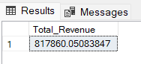

1. Average Order Value :

SELECT (SUM(total_price) / COUNT(DISTINCT order_id)) AS Avg_order_Value FROM pizza_sales

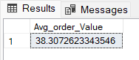

1. Total Pizzas Sold :

SELECT SUM(quantity) AS Total_pizza_sold FROM pizza_sales

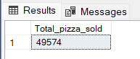

1. Total Orders :

SELECT COUNT(DISTINCT order_id) AS Total_Orders FROM pizza_sales

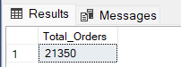

1. Average Pizzas Per Order :

SELECT CAST(CAST(SUM(quantity) AS DECIMAL(10,2)) /

CAST(COUNT(DISTINCT order_id) AS DECIMAL(10,2)) AS DECIMAL(10,2))

AS Avg_Pizzas_per_order FROM pizza_sales

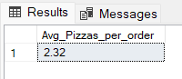

1. Daily Trend for Total Orders :

SELECT DATENAME(DW, order_date) AS order_day, COUNT(DISTINCT order_id) AS total_orders FROM pizza_sales

GROUP BY DATENAME(DW, order_date)

Output:

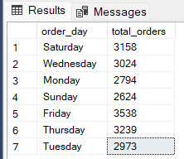

1. Monthly Trend for Orders

select DATENAME(MONTH, order_date) as Month_Name, COUNT(DISTINCT order_id) as Total_Orders

from pizza_sales

GROUP BY DATENAME(MONTH, order_date)

OUTPUT:

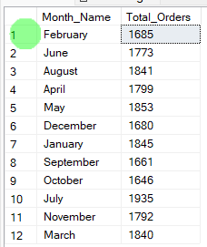

1. % of Sales by Pizza Category:

SELECT pizza_category, CAST(SUM(total_price) AS DECIMAL(10,2)) as total_revenue,

CAST(SUM(total_price) * 100 / (SELECT SUM(total_price) from pizza_sales) AS DECIMAL(10,2)) AS PCT

FROM pizza_sales

GROUP BY pizza_category

Output

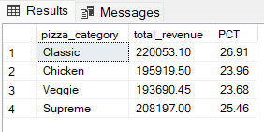

1. % of Sales by Pizza Size:

SELECT pizza_size, CAST(SUM(total_price) AS DECIMAL(10,2)) as total_revenue,

CAST(SUM(total_price) * 100 / (SELECT SUM(total_price) from pizza_sales) AS DECIMAL(10,2)) AS PCT

FROM pizza_sales

GROUP BY pizza_size

ORDER BY pizza_size

Output:

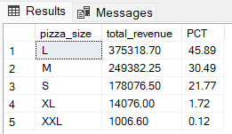

1. Total Pizzas Sold by Pizza Category:

SELECT pizza_category, SUM(quantity) as Total_Quantity_Sold

FROM pizza_sales

WHERE MONTH(order_date) = 2

GROUP BY pizza_category

ORDER BY Total_Quantity_Sold DESC

Output:

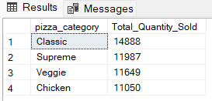

1. Top 5 Pizzas by Revenue:

SELECT Top 5 pizza_name, SUM(total_price) AS Total_Revenue

FROM pizza_sales

GROUP BY pizza_name

ORDER BY Total_Revenue DESC

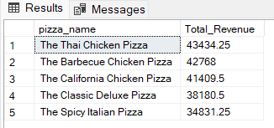

1. Bottom 5 Pizzas by Revenue:

SELECT Top 5 pizza_name, SUM(total_price) AS Total_Revenue

FROM pizza_sales

GROUP BY pizza_name

ORDER BY Total_Revenue ASC

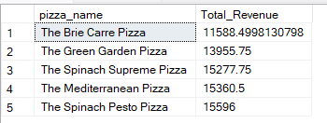

1. Top 5 Pizzas by Quantity:

SELECT Top 5 pizza_name, SUM(quantity) AS Total_Pizza_Sold

FROM pizza_sales

GROUP BY pizza_name

ORDER BY Total_Pizza_Sold DESC

***Output***

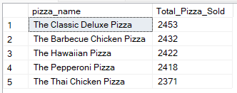

1. Bottom 5 Pizzas by Quantity:

SELECT TOP 5 pizza_name, SUM(quantity) AS Total_Pizza_Sold

FROM pizza_sales

GROUP BY pizza_name

ORDER BY Total_Pizza_Sold ASC

Output:

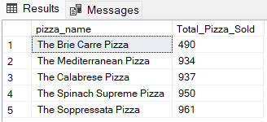

1. Top 5 Pizzas by Total Orders:

SELECT Top 5 pizza_name, COUNT(DISTINCT order_id) AS Total_Orders

FROM pizza_sales

GROUP BY pizza_name

ORDER BY Total_Orders DESC

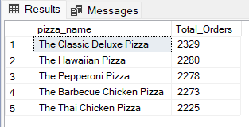

1. Bottom 5 Pizzas by Total Orders:

SELECT Top 5 pizza_name, COUNT(DISTINCT order_id) AS Total_Orders

FROM pizza_sales

GROUP BY pizza_name

ORDER BY Total_Orders ASC

